NAMAN KAUSHIK

170BTCCSE062

Assignment 2:WAP in Arduino to count the no. of person enter in a hospital, record their body temperature and generate an alert through buzzer if body temp is more than 98 F.

CircuitDiagram

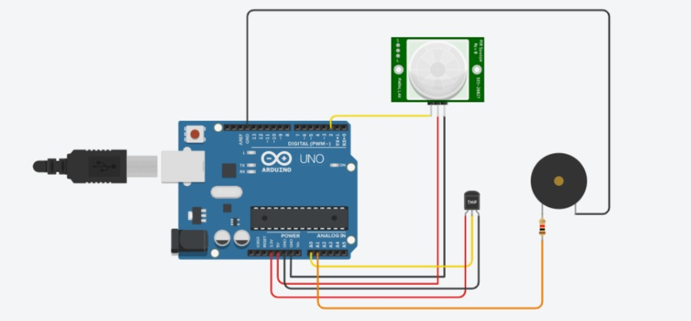

Code

int pirPin = 2;

int temppin= A0;

float temp=0;

int Buzz=A1;

int counter = 0;

int state;

int laststate = HIGH;

void setup(){

Serial.begin(9600);

pinMode(pirPin, INPUT);

pinMode(Buzz,OUTPUT);

}

void loop(){

int state = digitalRead(pirPin);

if ( state != laststate) {

temp=analogRead(temppin);

temp=temp\*0.48828125;

Serial.println(temp);

delay(1000);

if (temp>30)

{digitalWrite(Buzz,HIGH);}

else

{digitalWrite (Buzz,LOW);}

counter=counter+1;

Serial.println(counter);

}

else{

laststate = state;

delay(0);

}

}